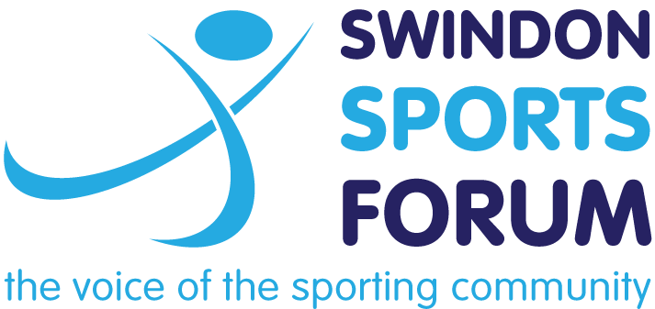

Young Athlete Academy

The Swindon Sports Forum is proud to introduce our new Young Athlete Academy, which aims to provide talented young sports people from Swindon with support to help them achieve their potential.
The Academy consists of regular Athlete Support days run by expert athletic development coach James Marshall. Each day will involve presentations of key principles to becoming a better athlete as well as practical activities to help improve numerous aspects of the athlete’s life and training.
James is an Athletic Development Coach specialising in coaching teenage athletes from many different sports, 7 of whom have represented GB at the Olympics/ Paralympics and 4 of whom are in the current England rugby squad. James understands that movement is key to performing in sport. He is constantly finding different ways to teach and refine better movement with all his athletes. He is the author of “Training Young Athletes” and Head Coach of Excelsior Athletic Development Club.
The next event will take place on:
Details for 2019/2020 Talented Athletes Academy will be announced in due course
There will be a presentation on Long Term Athletic Development at the start of the day which parents are welcome to stay for, before workshops on functional movement, planning your training, and building a strong foundation.
Places in the academy are limited and will be awarded solely based on the content of the application form. The programme is free however we expect athletes to commit to all sessions, failure to attend may result in a place being forfeited and given to another athlete.
Application form
Name
Sport
Club
School/College
Date of Birth
What is the highest level you have competed at in your sport
In no more than 500 words, explain why would like to be a part of the young athlete academy
Parent/Guardian Contact Details:
Phone

Email

Please advise of any necessary medical information

Please return completed form to Chris Baker at chris@wiltssport.org

